Advantage of Inheritance & Best Practice:
Key Benefits of Inheritance
1. Code Reusability
- Child classes can reuse methods and fields from parent classes.
- Reduces duplicate code (e.g., Animal class with eat(), sleep() reused in Dog and Cat).
2. Hierarchical Structure
- Logical organization of classes (e.g., Vehicle → Car → ElectricCar).
- Improves readability and maintainability.
3. Polymorphism Support
- Child classes can override parent methods.
- Runtime behavior depends on object type (e.g., Shape → Circle.draw() vs Square.draw()).
4. Easier Maintenance
- Changing a parent class automatically updates all child classes.
- Bug fixes/updates in one place affect all subclasses.

Best Practices for Using Inheritance
1. Prefer Composition Over Inheritance
- Use "has-a" (composition) instead of "is-a" (inheritance) when possible.
✅ Good:
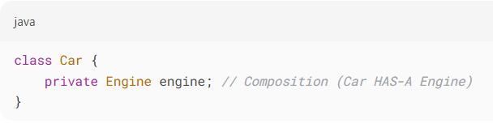
❌ Bad:
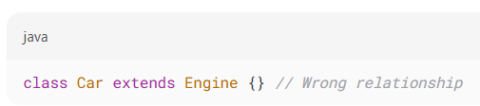
2. Follow the "Is-A" Rule
- Only use inheritance if a child truly is a specialized version of the parent.
✅ Valid: Dog extends Animal (Dog is an Animal)
❌ Invalid: CoffeeMachine extends Database (No logical relation)
3. Use Abstract Classes & Interfaces Wisely
- Abstract Class: When subclasses share common code.
- Interface: When multiple behaviors are needed (Java supports multiple interface inheritance).
4. Avoid Deep Inheritance Chains
- More than 3-4 levels of inheritance makes code hard to debug.
❌ Bad: A → B → C → D → E → F (Too complex!)
5. Don’t Use Inheritance Just for Code Reuse
- If two classes aren’t logically related, use composition + delegation instead.

Conclusion
- Inheritance is powerful but can lead to tight coupling if misused.
- Follow "is-a" relationships, avoid deep hierarchies, and prefer composition when possible.
- Use interfaces for flexibility (multiple inheritance-like behavior).
Golden Rule:
"Inherit only when there’s a true parent-child relationship, else use composition!"

